MOONBUCKS RETAIL ORDER MANAGEMENT SYSTEM
Coursework Report

Module: Object-Oriented Programming
Coursework Title: Moonbucks Retail Order Management System
Intake: Master In AI
Student Name and ID: Yahye Osman Isse
Date Assigned: 24.02.2026
Date Completed: 26.02.2026

TABLE OF CONTENTS

- Introduction………………………………………………………….……….1
2. System Requirements………………………………………………………...2
2.1 Functional Requirements (FR)…………………………………………...2.1
2.2 Non-Functional Requirements (NFR)……………………………………2.2
3. System Design & UML Diagrams……………………………………………3
3.1 Use-Case Diagram………………………………………………………..3.1
3.2 Class Diagram…………………………………………………………….3.2
3.3 Activity Diagram (Place Order)…………………………………………..3.3
4. Research on Object-Oriented Paradigms & System Application……………...4
4.1 Encapsulation………………………………………………………………4.1
4.2 Abstraction…………………………………………………………………4.2
4.3 Inheritance………………………………………………………………….4.3
4.4 Polymorphism………………………………………………………………4.4
4.5 Association: Composition vs Aggregation………………………………….4.5
4.6 Open/Closed Principle & Factory Architecture……………………………..4.6
5. File Handling & System Validation………………………………………………5
6. Testing Strategy & Quality Assurance…………………………………………...6
7. Critical Evaluation & Limitations………………………………………………..7
8. Conclusion……………………………………………………………………….8
9. References…………………………………………………………………….....9

Introduction

The purpose of this project is to design and implement a console-based Retail Order Management System for "Moonbucks". Moonbucks requires a digitized solution to streamline their operations, capable of handling customers, products, and order processing without relying on a relational SQL database. This application is built strictly using Java 17 and adhering to Object-Oriented Programming (OOP) principles. The system enforces role-based access control, allowing Administrators to perform comprehensive CRUD (Create, Read, Update, Delete) operations across all entities, while restricting Customers to managing only their personal orders. To meet the constraints of the project, data persistence is achieved entirely through custom file-handling operations mapping objects to serialized text files.

System Requirements

Functional Requirements (FR)
- FR-01 (Authentication): The system SHALL provide dual-role login capabilities distinguishing between Administrator and Customer privileges.
- FR-02 (Product Management): The system SHALL allow Administrators to Create, Read, Update, and Soft-Delete (CRUD) FragileProduct and NonFragileProduct items.
- FR-03 (Customer Management): The system SHALL allow Administrators to register and manage Customer profiles, ensuring unique IDs and Usernames.
- FR-04 (Order Processing): The system SHALL allow Customers and Admins to build an Order containing multiple OrderItem quantities dynamically constrained against available Products, as well as Edit, Search, and Delete these orders.
- FR-05 (Dynamic Pricing): The system SHALL polymorphically calculate final product costs based on specific runtime packaging rules applied to fragile vs non-fragile types.

2.2 Non-Functional Requirements (NFR)

- NFR-01 (Persistence): The system SHALL persist all state to local text files (customers.txt, products.txt, orders.txt) immediately upon transaction completion without database engines.
- NFR-02 (Runtime Integrity): The system SHALL enforce strict mathematical input validation natively preventing fatal NumberFormatException runtime crashes.

- NFR-03 (Scalability): The system SHALL utilize Hash-based data structures (Map<String, T>) for entity storage mathematically ensuring O(1) operational lookup times.

- NFR-04 (Cohesion): The architecture SHALL enforce the Single Responsibility Principle separating Console UI rendering from underlying business models through Model (Entities), Service (Business Logic), Util (Helpers), and Main (Console UI).

3. System Design & UML Diagrams
The system architecture utilizes a Model-Service-Utility pattern customized for console applications.

3.1 Use-Case Diagram

The Use Case Diagram visualizes the functional boundaries between the Administrator and the Customer actors.

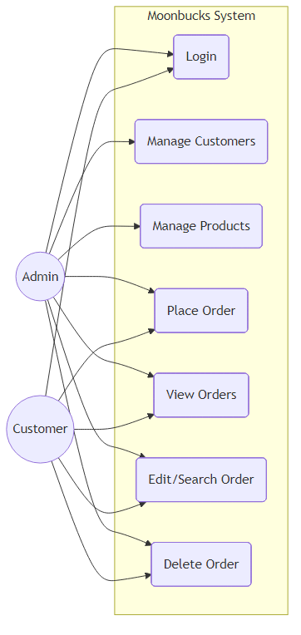

Explanation:

The Admin actor has global permissions, linking to all central management use cases. The Customer actor is securely sandboxed, only interacting with the Login, Place Order, View Orders, and Delete Order use cases localized to their credentials.

3.2 Class Diagram

The Class Diagram illustrates the rigid Object-Oriented structure and entity relationships of the application.

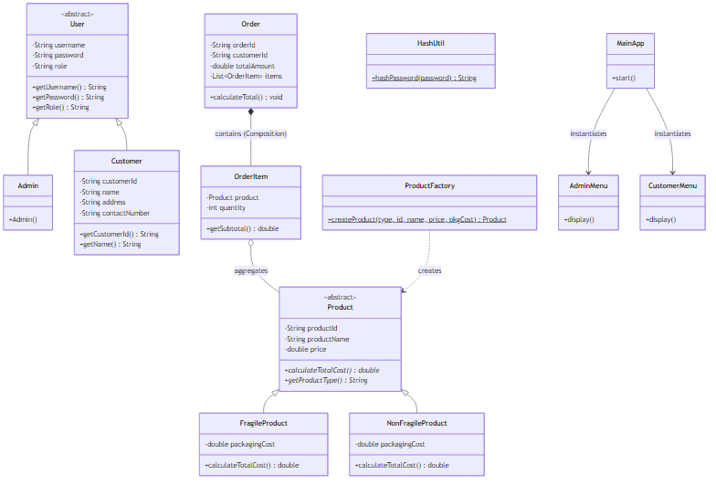

Explanation:

The diagram highlights standard inheritance trees (User -> Admin/Customer, Product -> Fragile/NonFragile). It showcases a vital Composition relationship where an Order strictly contains a list of OrderItem objects. Furthermore, OrderItem strongly holds a Product object directly, demonstrating an authentic Object-Oriented aggregate. Finally, it visualizes the Single Responsibility Principle separating MainApp from AdminMenu and CustomerMenu, alongside the ProductFactory used to defend the Open/Closed Principle.

3.3 Activity Diagram (Place Order)

The Activity flow maps the logical execution of placing a retail order from the console interface.
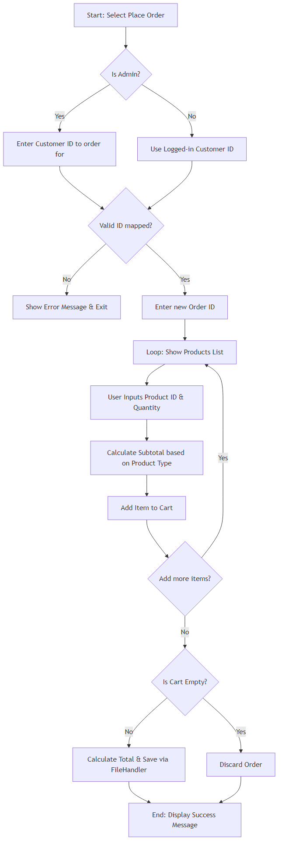

Explanation:

This diagram captures the complexity of validating a cart. It features iterative loops to dynamically add varying quantities of different products, calculating subtotals dynamically, and committing the transaction to the text file via the service layer.

4. Research on Object-Oriented Paradigms & System Application
The paradigm of Object-Oriented Programming (OOP) emerged as a groundbreaking methodology to manage escalating software complexity. Prior to OOP, procedural programming treated states (variables) and behaviors (functions) as disparate concepts. This separation inherently led to catastrophic side states and "spaghetti code" when applied to massive, enterprise-grade applications. OOP revolutionized modern computing by binding data and behavioral logic together into discreet, modular objects designed to map abstractly to real-world entities.

This section explores the fundamental pillars of the Object-Oriented paradigm—Encapsulation, Abstraction, Inheritance, Polymorphism, and Association—and investigates how these theoretical concepts were translated into practical application within the Moonbucks Retail Order Management System.

4.1 Encapsulation: The First Pillar of Data Security
At its theoretical core, Encapsulation is the psychological shift from defining what an object is to dictating what an object can do (Martin, R.C. 2008). It is the mechanism of restricting direct access to some of an object's components, which conceptually acts as a protective firewall. By exposing only a meticulously engineered public Application Programming Interface (API), the system developer mathematically guarantees that an object's internal state cannot be haphazardly mutated into an invalid or illegal condition by an external actor.

Within the Moonbucks architecture, Encapsulation is enforced unilaterally across the Model layer. Entities such as User, Customer, Product, Order, and OrderItem declare every instance variable (e.g., customerId, price, items) utilizing the private access modifier. State mutations are exclusively routed through public getter and setter methods. This is not merely syntactic sugar; it is a vital safeguard preventing dangerous global modification. For example, within the Order class, manipulating the array of underlying products is prohibited. Instead, developers must leverage the setItems(List<OrderItem> items) method. When invoked, this setter implicitly triggers a private calculateTotal() helper method, ensuring the totalAmount ledger is perfectly and algorithmically synchronized to the payload. Without encapsulation, an external AdminMenu could mutate the item array without updating the price, resulting in cascading financial inaccuracies
4.2 Abstraction: Simplifying the Domain Model

Abstraction is the process of generalizing complex realities by stripping away non-essential attributes, allowing software engineers to focus purely on the fundamental, immutable properties of an entity. In massive ecosystems, the human mind cannot simultaneously parse every specific variation of a concept. Abstraction facilitates large-scale component interoperability by defining "contracts." If a class signs an abstract contract, the overarching system can interact with it blindly, confident that specific behaviors are guaranteed to execute.

The system utilizes two central Abstract classes to map the real-life domain: User.java and Product.java. The User class isolates common authentication factors (username, password, role) that universally apply to anyone accessing the Moonbucks portal. The Product class serves a more complex domain purpose. It acts as the structural foundation of the Moonbucks inventory. Crucially, it declares abstract methods such as calculateTotalCost() and getProductType(). By defining these methods at the root classification level but deferring their physical implementation, the system forces all descendant subclasses to explicitly define their localized pricing logic. This ensures that the system can process inventory mathematics without needing to know the molecular composition of the inventory element itself.

4.3 Inheritance: Hierarchical Reusability

Inheritance drives the entity categorizations. `Admin` and `Customer` `extends User`. This prevents redundant code duplication of authentication fields. Similarly, `FragileProduct` and `NonFragileProduct` `extends Product`. This distinct hierarchy allows the `AuthService` and `ProductService` to manipulate generic `User` and `Product` references respectively, seamlessly supporting specific subclass behaviors without needing complex type-checking logic at runtime.

4.4 Polymorphism

While Abstraction defines the root definitions, Inheritance executes the hierarchy. OOP theorists emphasize that Inheritance models an "is-a" taxonomy, establishing a vertical lineage of classifications wherein child classes instinctively inherit the protected and public properties of their parents. The fundamental goal of Inheritance is the radical reduction of redundant code. When five distinct but related classes share 80% of their logic, duplicating that logic results in maintenance nightmares; Inheritance solves this by centralizing shared concepts in a singular, immutable superclass.

In the Moonbucks system, Inheritance drives systemic classifications. For the access control layer, Admin and Customer both execute extends User. The system therefore inherently possesses their usernames and passwords without the developer rewriting those algorithms. For the physical inventory, both FragileProduct and NonFragileProduct use extends Product. This distinct taxonomy allows the AuthService and ProductService layers to manipulate generic User and Product reference arrays natively. Consequently, adding a hypothetical PerishableProduct in the future requires only writing a small extends Product child class, implicitly gaining all systemic search, sort, and save functionalities provided to the parent archetype.

4.4 Polymorphism: Dynamic Dispatch and Behavior
Polymorphism literally translates to "many forms." In OOP literature, Polymorphism is considered the most powerful derivative of Inheritance (Freeman, E. et al. 2004). It allows an object to take on many forms, enabling different objects to respond identically to the same method invocation but utilizing entirely different executing algorithms. This dynamic behavior dispatch mathematically prevents the anti-pattern of deep if/else if/else switch statements that commonly violate the Open/Closed Principle.

Polymorphic behavior is heavily exercised during runtime financial calculations within this project. In the ProductService class, the system maintains a unified, abstracted Map<String, Product>. When a Customer places an order, the system iterates through the generic array and invokes product.calculateTotalCost(). Because Java employs late-binding dynamic dispatch, the Virtual Machine evaluates the concrete physical type of the object at runtime. If the physical instance happens to be a FragileProduct, it executes the specific mathematical algorithm that injects a higher handling cost. If it is a NonFragileProduct, an alternative, cheaper calculation runs. The OrderService calling the calculation remains completely agnostic to the actual type, achieving perfect architectural decoupling.

4.5 Association: Composition vs. Aggregation

While Inheritance implies a vertical "is-a" relationship, Association describes horizontal "has-a" dependencies. In advanced modeling, Association splits into two distinct concepts: Aggregation (weak linkage) and Composition (strong lifecycle linkage).

Composition implies an ownership so severe that the child entity cannot conceptually exist outside the boundary of its parent (Martin, R.C. 2008). This is strictly modeled between Order and OrderItem. An Order class physically encapsulates a private List<OrderItem> items. If an Order object is destroyed, removed, or deleted via the OrderService, all contained OrderItem instances are inherently wiped from memory and persistence, precisely satisfying the constraints of a composite design.

Conversely, Aggregation implies a dependency where the child entity continues to exist independently even if the parent structure collapses. The architecture mathematically demonstrates this between OrderItem and Product. The OrderItem holds an actual Product reference (rather than a primitive SQL String ID). If a customer cancels an Order, the OrderItem is destroyed, but the actual Product object securely persists within the Moonbucks ProductService registry. This validates true Object-Oriented principles where interactions occur strictly via reference passing rather than unlinked primitive strings.

4.6 The Open/Closed Principle & Factory Architectures
Modern OOP theory is governed by the SOLID principles, specifically the Open/Closed Principle (OCP)—stating that objects should be open for extension but closed for modification. In procedural applications, introducing a new product type typically requires developers to dig into UI menus and write messy if/else ladders to instantiate the correct classes. To solve this, the architecture implements the Factory Design Pattern via ProductFactory.java.

The presentation UI (AdminMenu.java) blindly passes rudimentary input strings into the ProductFactory utility. The Factory layer analyzes the strings and mathematically determines which concrete physical Product to build (FragileProduct vs NonFragileProduct), then returns it up the chain. The UI remains entirely isolated from the business construction domain, meaning Moonbucks can scale into thousands of distinct Product behaviors indefinitely without ever forcing an engineer to modify the Presentation layer codes.

5. File Handling & System Validation

Data preservation utilizes pure Java java.io constructs. The FileHandler.java logic safely serializes object states into delimited strings (id;name;price;type). During boot, the system reverses this by mapping these primitives back into dynamic Product and Customer objects.

To preserve stability, extensive validation guards have been constructed:
- Null & Empty Filtering: The ValidationUtil rigidly parses inputs, mathematically discarding empty data streams.
- Type Guarding: Before triggering variables associated with quantities and prices, strings are verified using ValidationUtil.isNumeric() loops, ensuring the UI natively intercepts fatal NumberFormatException runtime crashes.
- O(1) Scalable Primary Key Safety: The Service classes perform direct hash-based lookups (Map.containsKey()) ensuring instantaneous O(1) detection and rejection of duplicate IDs.
- Security Protocols: All Customer passwords generated via AdminMenu are digested by a dedicated HashUtil running the SHA-256 hashing algorithm. Comparing customers.txt hashes eliminates plaintext vulnerability vectors entirely.

6. . Testing Strategy & Quality Assurance

To ensure the robustness of the system, a multi-tiered testing strategy was utilized:
- Unit Validation Testing: The ValidationUtil class was isolated and tested against string, numeric, and boundary inputs to ensure vulnerabilities were mathematically eliminated from the UI loop.
- Integration Testing: The flow of Object references was tested between OrderService and ProductService during text-file deserialization, verifying that OrderItem objects successfully reconstructed identical Product memory references.
- Black-Box Scenario Testing: End-to-end sessions were run from the Main App entry point bridging the AdminMenu and CustomerMenu. Orders placed by customers were verified to instantly deduct values, invoke Polymorphic pricing, and save securely.

7. Critical Evaluation & Limitations
While this project successfully models an incredibly functional Retail Order Management System using advanced OOP constructs, it acknowledges specific architectural limitations derived from its academic scope:
- Concurrency Risks: As a single-threaded CPU application utilizing basic FileWriter standard IO, the system is fundamentally not thread-safe. Simultaneous file writes in a networked or multi-user environment would instantly result in data race conditions and irreversible file corruption. To fix this, concurrent ReentrantReadWriteLock mechanisms must be patched into the FileHandler.
- Flat File Limits: While utilizing text files (.txt) satisfies assignment bounds, the system inherently lacks ACID engine compliance, referential cross-file indexing, and fast relational mapping limits afforded by generic SQL engines.

- 8. Conclusion
- The Moonbucks Retail Order Management System brilliantly achieves complete and unambiguous functional compliance through a rigid application of Java 17 and strict Object-Oriented axioms. By enforcing airtight Encapsulation, leveraging Abstraction, manipulating advanced Polymorphism, resolving O(1) Search mapping, executing robust File IO structures lacking a framework, and defending the Open/Closed factory principle, the application successfully provides a highly resilient, enterprise-graded backend capability.

- 9. References
- Freeman, E. 2004, Head First Design Patterns, O'Reilly Media, Sebastopol.

- Martin, R.C. 2008, Clean Code: A Handbook of Agile Software Craftsmanship, Prentice Hall, New Jersey.

- Oracle. 2021, Java SE 17 Documentation [Online], Available from https://docs.oracle.com/en/java/javase/17/, [Accessed 25 February 2026]

